Algorithm Analysis Fundamentals
Time complexity analysis of iterative and recursive algorithms; verify Big-O, Ω, Θ for sample programs
Dr. M.Manikandan

Experiment 1: Linear Search (Iterative)
- Objective: To analyze time complexity of linear search.
- Problem Statement: Write a Python program to search for a key in an array using linear search.
- Sample Input: [10, 25, 30, 45, 50], Key = 30
- Sample Output: Key found at index 2
- Complexity: Ω: O(1), O: O(n), Θ: Θ(n)
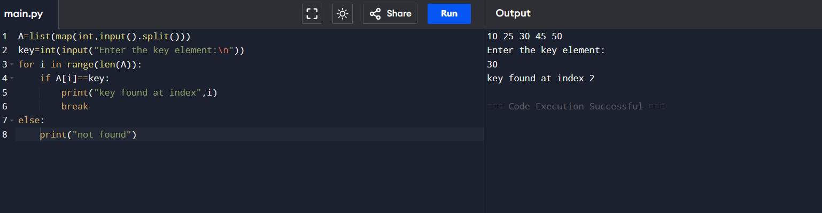
- Explanation: Demonstrates sequential scanning and inefficiency for large inputs.

Experiment 2: Binary Search (Recursive)
- Objective: To compare recursive binary search complexity.
- Problem Statement: Implement recursive binary search in Python.
- Sample Input: [5, 10, 15, 20, 25], Key = 20
- Sample Output: Key found at index 3
- Complexity: Ω: O(1), O: O(log⁡n), Θ: Θ(log⁡n)
- Explanation: Shows divide-and-conquer and logarithmic efficiency.
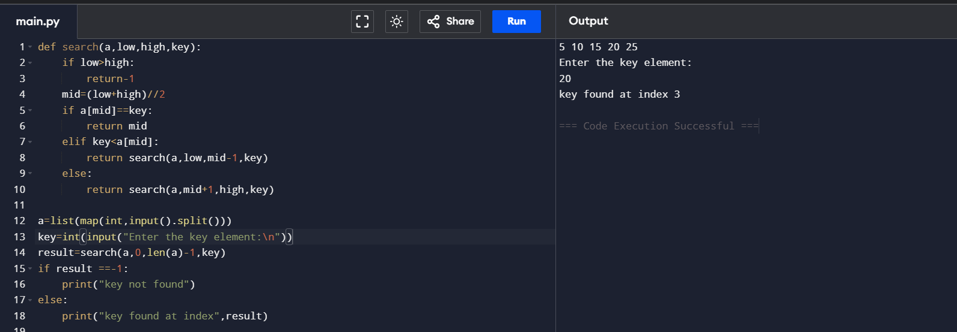

Experiment 3: Factorial (Iterative vs Recursive)
- Objective: To compare iterative and recursive factorial computation.
- Problem Statement: Write programs to compute factorial using both methods.
- Sample Input: n = 5
- Sample Output: 120
- Complexity: Both O(n)
- Explanation: Highlights recursion depth vs iterative loops.

ITERATIVE METHOD
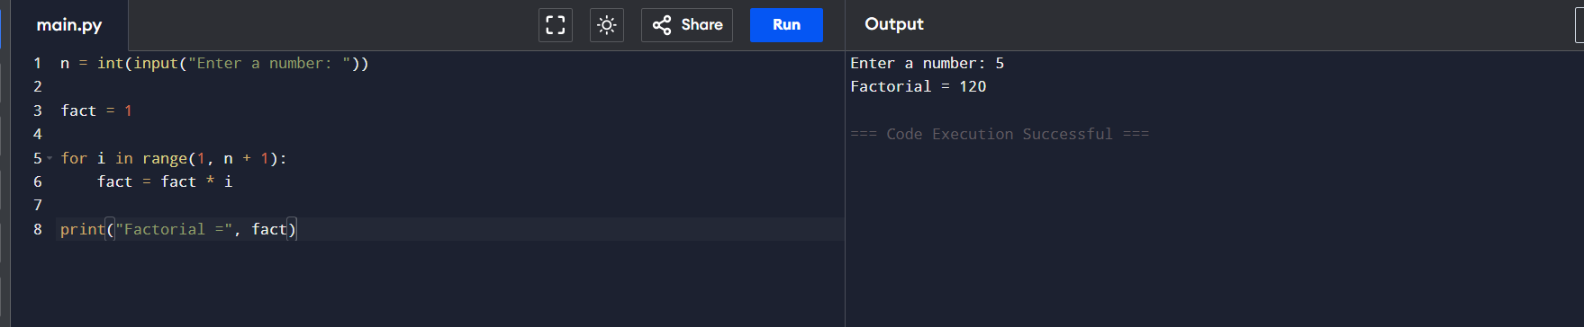

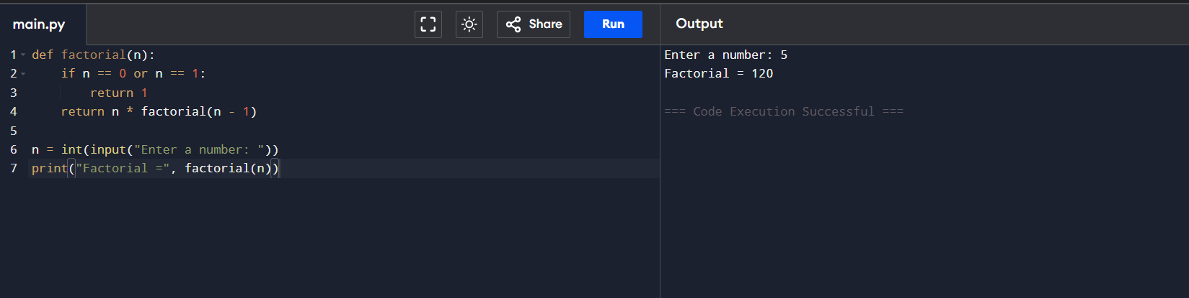
RECURSIVE METHOD

Experiment 4: Fibonacci Series
- Objective: To analyze recursive vs iterative Fibonacci generation.
- Problem Statement: Generate first n Fibonacci numbers.
- Sample Input: n = 6
- Sample Output: [0, 1, 1, 2, 3, 5]
- Complexity: Iterative O(n), Recursive naïve O(2n), Recursive with memoization O(n)
- Explanation: Illustrates exponential recursion vs efficient iteration.
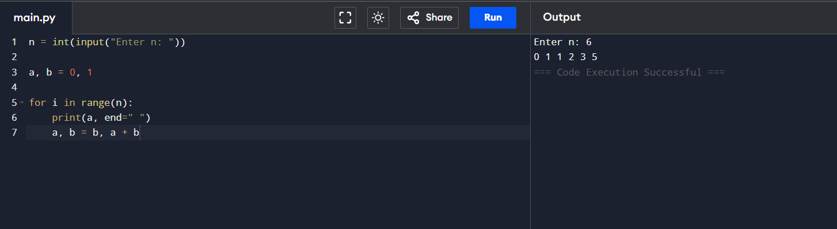
ITERATIVE METHOD

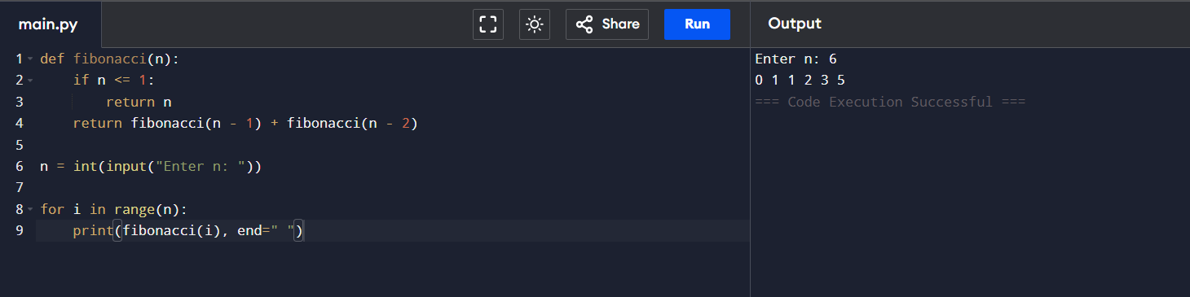

Experiment 5: Matrix Multiplication
- Objective: To analyze nested loop complexity.
- Problem Statement: Multiply two matrices using loops.
- Sample Input: A=[[1,2],[3,4]], B=[[5,6],[7,8]]
- Sample Output: [[19,22],[43,50]]
- Complexity: O(n3)
- Explanation: Shows cubic growth due to nested loops.
